
December 2, 2025

Attn: Boreth Long 6905 96th Ave SE
Mercer Island, WA 98040 Via: Email
COMMUNITY PLANNING & DEVELOPMENT
206.275.7605
www.mercerisland.gov/cpd

RE: ADU25-012 Review Letter 1; 6905 96th Ave SE, Mercer Island, WA 98040 Dear Boreth,
The City of Mercer Island Community Planning and Development Department has completed a review for compliance with the zoning code, Title 19 of the Mercer Island City Code (MICC) for the above Accessory Dwelling Unit application. The following issues need to be addressed in your resubmission:

- Please adjust the setbacks for the detached ADU on the plan set. Per MICC 19.02.020(C)(1)(c)(iii)(b), single-family dwellings with a height of more than 25 feet measured from the existing or finished grade, whichever is lower, to the top of the exterior wall facade adjoining the side yard shall provide a minimum side yard depth of ten feet. It appears the south exterior wall may exceed 25 feet and may need to demonstrate a minimum side yard of 10 feet. Please note that no part of the structure may protrude into a minimum yard, per MICC 19.02.020.(C)(3)(a)(ii).
Planning Department Response 12/3/25:
As for comment #1, there is concern the southern exterior wall may exceed 25 feet, highlighted in the image below. Please indicate the roof framing elevation for this asymmetrical roof design and the height of the exterior wall on the southern side. You are correct if the exterior wall is under 25 feet in height then it will not need to depict the 10 feet yard setback. Please demonstrate how the structure does not meet this code section on the
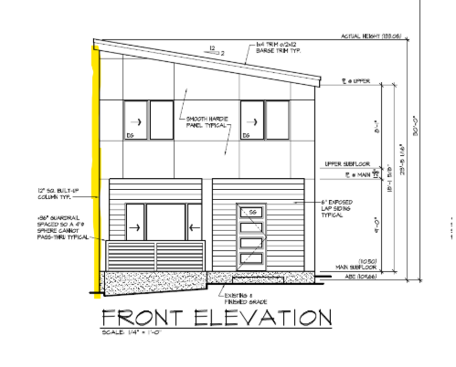
Applicant Response 1/7/2026:
As shown in Sheet A7: EXTERIOR ELEVATION, the ADU building height is 23ft 5 inches from the finished grade (ABE calculation) to the top of the exterior wall façade. Northwest architect revised Sheet A7 to show the height from the existing grade at the SE corner. This demonstrated that the building height is 24ft 9inches. It is less than 25 feet. Therefore, MICC 19.02.020(C)(1)(c)(iii)(b) is not applicable. We are following MICC 19.02.020(C)(1)(c)(iii)(a) which requires seven and one-half feet (7.5feet) of side yard. We currently have 8 feet of side yard because the roof will protrude 6in past the south exterior wall.

- Please depict the appropriate amount of parking on the planset. Per MICC 19.02.020(G)(2)(a), each single-family dwelling with a gross floor area of 3,000 square feet or more shall have at least three parking spaces sufficient in size to park a passenger automobile. Per MICC 19.02.030(B)(9)(c), two off-street parking spaces are required per unit with development of accessory dwelling units on lots greater than 6,000 square feet before any zero lot line subdivisions or lot splits. For parking dimensions, see MICC 19.02.020(G)(7). Parking spaces in tandem shall count towards meeting minimum parking requirements at a rate of one space for every 20 linear feet with any necessary provisions for turning radius. For purposes of this subsection, "tandem" is defined as having two or more vehicles, one in front of or behind the others with a single means of ingress and egress.

Applicant Response 1/7/2026:
Currently, there are a total 4 existing parking spaces as shown on Sheet A0 Site Plan (see snapshot below). We made a decision to remove dilapidated and unused chicken COOP and shed as shown in sheet A0. This reduces the gross floor area from 3172sqft to 2930sqft. Therefore, per MICC 19.02.020(G)(2)(b), each single-family dwelling with a gross floor area less than 3,000 square feet shall have at least two parking spaces sufficient in size to park a passenger automobile. With 4 parking spaces, this should satisfy and resolve the comment above.

Recently, we also received comments from the building permit review with recommendation to remove the shed since it may not have permit when it was build years ago before we bought the property.

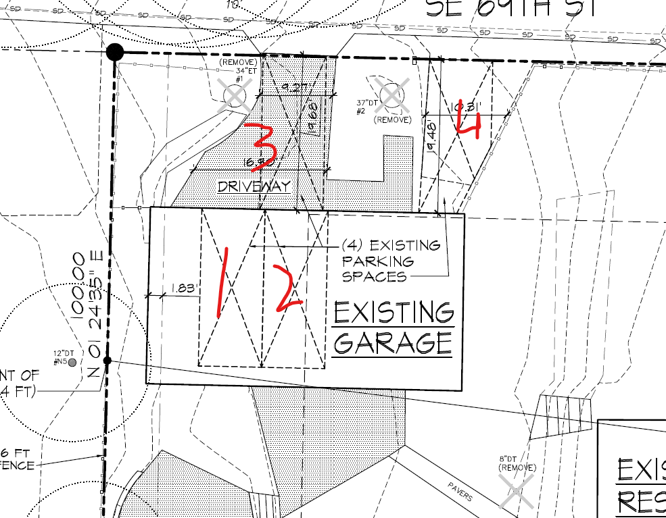

- Please describe the height of the retaining wall. Per MICC 19.02.050(D)(4)(a), no retaining walls or rockeries, or any combination of retaining walls or rockeries, to the extent used to protect a cut or cuts into existing grade within any required yard, shall exceed a total of 144 inches in height. If it is a fill slope, per MICC 19.02.050(D)(5)(a), no retaining walls or rockeries, or any combination of retaining walls or rockeries, to the extent used to raise grade and protect a fill slope, shall result in an increase in the finished grade by more than 72 inches at any point. For retaining walls outside of required yards, please see MICC 19.02.050(C)(3), retaining walls outside of required yard setbacks shall be stepped to meet a 1:1 ratio of separation with 45 degrees of grade to be considered separate. For example, two six-foot-tall retaining walls would need to be separated by at least six feet of horizontal distance measured from the toe of the upper wall to the top of the bottom wall, to be considered separate and not combined for maximum height calculations.

Applicant’s Follow Up Question 12/2/25:
As shown in Sheet A0: SITE PLAN, the height of the retaining wall around the ADU is ranging from 1ft to 2.6 ft. The Architect labels the height at top of the retaining wall (i.e. 112.06’) and the bottom of the retaining wall (i.e. 110.0”). Subtracting the height at the top and the bottom of the retaining wall, we can determine the total height of the retaining wall. As you can see, the retaining wall around the ADU is well below 144inches requirement described in MICC 19.02.050(D)(4)(a)

Planning Department Response 12/3/25:
As for comment #3, thank you for clarifying this issue. I did miss this notation during my review of the planset. This comment may be considered resolved.

- Please update the planset to remain consistent with associated permit 2508-232.

Applicant’s Response 1/7/2026:
On 12/30/2026, we received comments from the buildering permit 2508-232, there are about 20 comments and we are working to resolve them. There will be some additional updates from this Plan Set Revision 1. We will keep you informed and ensure both review are consistent.

The City’s processing of the Accessory Dwelling Unit application has been put on hold until these issues are resolved. Pursuant to MICC 19.15.110, all requested information must be submitted within 60 days or a request for extension requested. The deadline for a complete response or request for extension is January 31, 2026. If a complete response is not received or an extension response has not been received prior to that date, the application will expire and be canceled for inactivity. No additional notification regarding this deadline or expiration of the application will be provided.

Sincerely,
Madelyn Nelson
Madelyn Nelson, Assistant Planner
City of Mercer Island Community Planning and Development madelyn.nelson@mercerisland.gov
(206) 275-7704

Responding and Resubmitting: Click for More Detailed Instructions
  - Reply to all review comments within the correction letter.
  - Update your drawings, and any necessary supplemental documents or forms.
  - Upload updated drawings to the Mercer Island Permit Submittal Portal.

Having Trouble? Please Review the Following:
Accessing, Reviewing, and Responding to MIePlan Comments Troubleshooting MIePlan
MIePlan Overview

Thank you for your participation in the MIePlan review process.

